Module 3.4: Impact of Carbon Dioxide Emissions on the Ocean’s pH and Food Web
Day 2: Sage Modeler Instructions
Follow these steps with your team and use SageModeler to explore how the ocean’s pH and foodweb are impacted by carbon dioxide emissions.

- Visit the SageModeler website. The first scenario you will explore is how seawater is impacted by carbon dioxide emissions.
- As a group, take a moment to make observations of the model. In particular, view the connections to the icons and their potential relationships. Answer the following questions:
- How does carbon dioxide get introduced into the Earth’s system in the model?

- After you’ve made your observations, take a moment to make a prediction with your group on how you think increasing carbon dioxide emissions might impact the ocean.
- How might increases in these sources of carbon dioxide impact the Earth’s system?

- Once you have made your prediction, it is time to test it. To test your prediction, click on the “Simulate” menu in the upper right-hand corner of the platform. You’ll notice that your model in the workspace changes.


- You’ll notice that sliding bars appear next to Factory CO₂ Emissions and Car CO₂ Emissions. These are variables that you can modify. The gray bars signify the measurement of its respective variable.
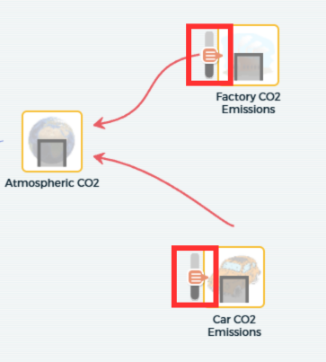

- Take a moment to manipulate the simulation to make the ocean’s pH more basic (higher ocean pH).
- What do you notice about the system when the ocean’s pH is more basic?
- How do basic conditions in the ocean’s pH impact the organisms in the food web?

- Now, make the ocean’s pH more acidic by adjusting your model (lower ocean pH).
- What do you notice about the system when the ocean’s pH is more acidic?
- How does making the conditions more acidic in the ocean’s pH impact the organisms compared to basic conditions?

- What differences do you notice between increasing and decreasing the amount of carbon dioxide and the impacts it has on the living organisms in this model?

